

RAJALAKSHMI ENGINEERING COLLEGE, CHENNAI

EXPERIMENT 6
CDN Service Selection and CDN Configuration

Aim
To select a Content Delivery Network (CDN) provider, deploy a simple web application using Cloudflare, access the application through Cloudflare's edge network, and verify the HTTP response and Cloudflare-specific headers using browser Developer Tools.

What Is a Content Delivery Network?
A Content Delivery Network (CDN) is a distributed network of servers or edge locations used to deliver web content closer to users. Instead of every request travelling directly to a distant origin server, CDN/edge infrastructure can process and deliver content from locations distributed across the network. This reduces latency and improves the user experience. Cloudflare also provides edge compute through Workers, where application code executes directly on Cloudflare's network.

Why Do We Need a CDN?
Suppose your website's original server is in the USA, but a student in Chennai accesses it.
Without a CDN:
Student in Chennai
|
| Internet
v
Server in USA
|
v
Website
The request has to travel a long distance.
With a CDN:
Student in Chennai
|
v
Nearby CDN / Edge Location
|
v
Website content

What Is Cloudflare?
Cloudflare helps websites become faster, safer, and more reliable by placing its network between users and the website. It is a cloud platform that provides services such as CDN, DNS, security, and edge computing. In this experiment, Cloudflare Workers was used to deploy a simple application on Cloudflare's distributed edge network, demonstrating how a user's request can be processed and served through the cloud edge.

Where Does Cloudflare Come In?
Cloudflare operates a large distributed network of edge locations. Conceptually:
Cloudflare
Global Edge Network
/ | \
/ | \
India Singapore USA
| | |
v v v
User User User
When a website uses Cloudflare's CDN/proxy services, Cloudflare can handle requests at its edge network.

Why Did We Use Cloudflare?
The task was to research and select a CDN provider such as Cloudflare, Akamai, or Amazon CloudFront. The options considered were:
Provider | Purpose
Cloudflare | CDN + security + DNS + edge computing
Amazon CloudFront | AWS CDN
Akamai | Enterprise CDN

Cloudflare was selected because it was the easiest option for a practical experiment.

Procedure

Part A – Deploying a Worker on Cloudflare

Step 1: Select the CDN / Edge Provider
Cloudflare was selected as the CDN/edge provider for this experiment.
Open the Cloudflare sign-up page (dash.cloudflare.com/sign-up) and create or log into a Cloudflare account. DNS/nameserver settings were left unchanged, since this experiment only needed a Worker, not a custom domain.
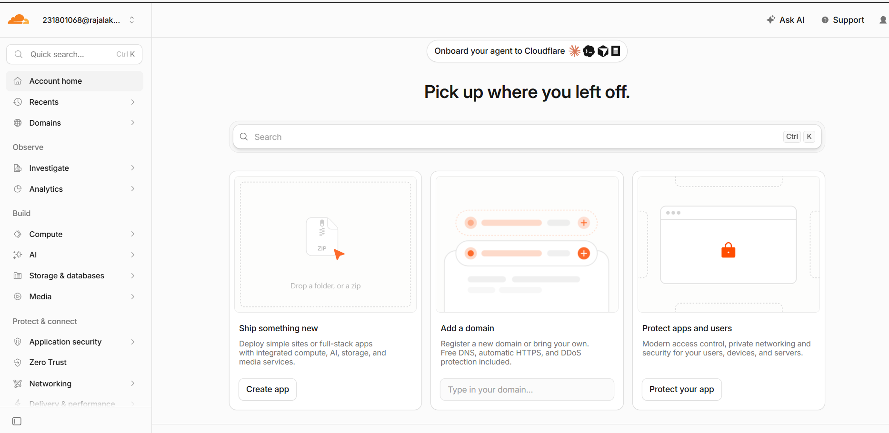
Figure 1: Cloudflare account dashboard after logging in.

Step 2: Create a Worker
On the dashboard, the "Ship something new" card was used, and Create app was clicked to begin creating a new Worker.

Step 3: Choose a Deployment Method
Cloudflare presented several options for creating the application:
• Connect GitHub
• Connect GitLab
• Start with Hello World!
• Select a template
• Upload your static files
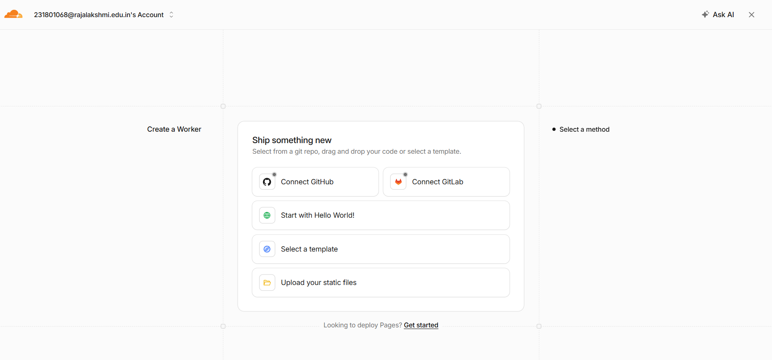
Figure 2: Available methods for creating a new Worker.

Step 4: Start with Hello World!
"Start with Hello World!" was selected, since it is the simplest option and does not require connecting a GitHub or GitLab repository.
Cloudflare auto-generated a Worker name and pre-filled a starter script that simply returns the text “Hello World!”. The default worker name and code were left unchanged at this stage.
return new Response('Hello World!');
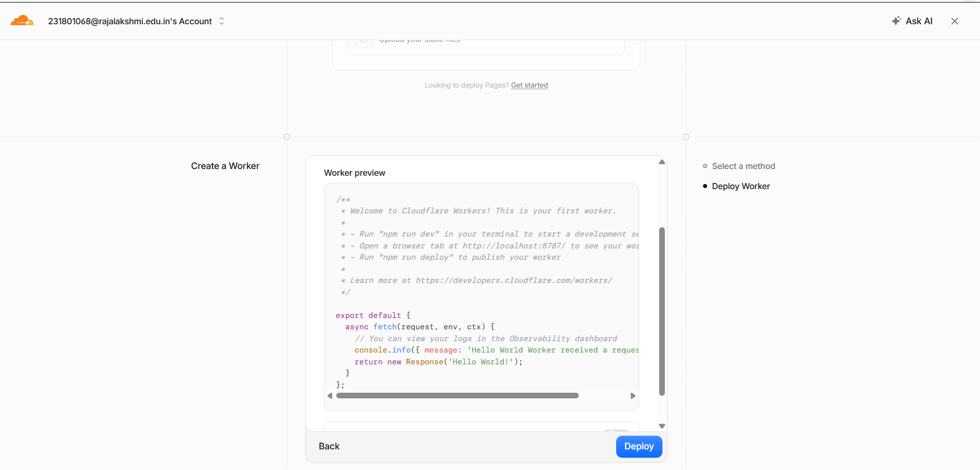
Figure 3: Worker preview showing the default Hello World script before deployment.

Step 5: Deploy the Worker
The blue Deploy button was clicked, and Cloudflare finished deploying the Worker within a few seconds.
Cloudflare created a public address for the application ending in workers.dev, in the form:
https://<worker-name>.<account-id>.workers.dev
For this experiment, the deployed Worker's public URL was:
https://super-sound-f86d.231801068.workers.dev
The deployment screen confirmed: a workers.dev domain was created, the version was deployed successfully, and both Errors and Invocations were 0 since nobody had visited the URL yet.

Part B – Testing the Deployed Application

Step 1: Visit the Worker
Clicking Visit opened the Worker in a new browser tab, which displayed:
Hello World!
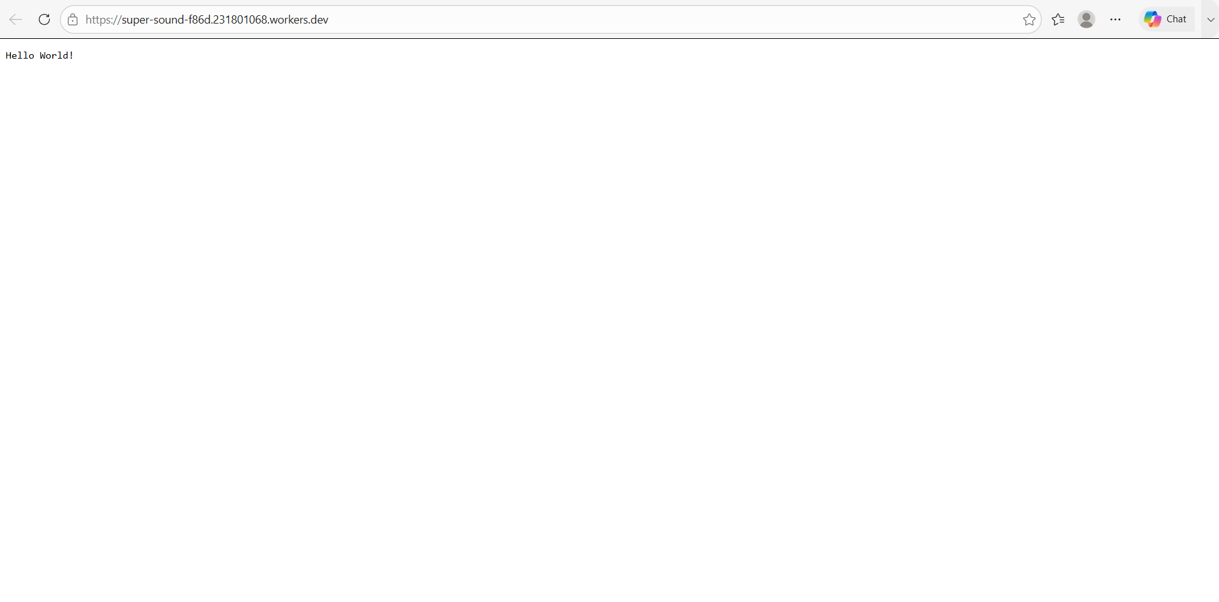
Figure 4: The deployed Worker responding with “Hello World!” in the browser.

Step 2: Confirm the Result
Seeing “Hello World!” confirmed that the Cloudflare application was working successfully. ✅

Step 3: Check the Invocation Count
Returning to the Cloudflare dashboard, the Metrics panel showed that after visiting the URL, Invocations increased from 0 to at least 1 — practical proof that a real request reached the Cloudflare-hosted Worker.
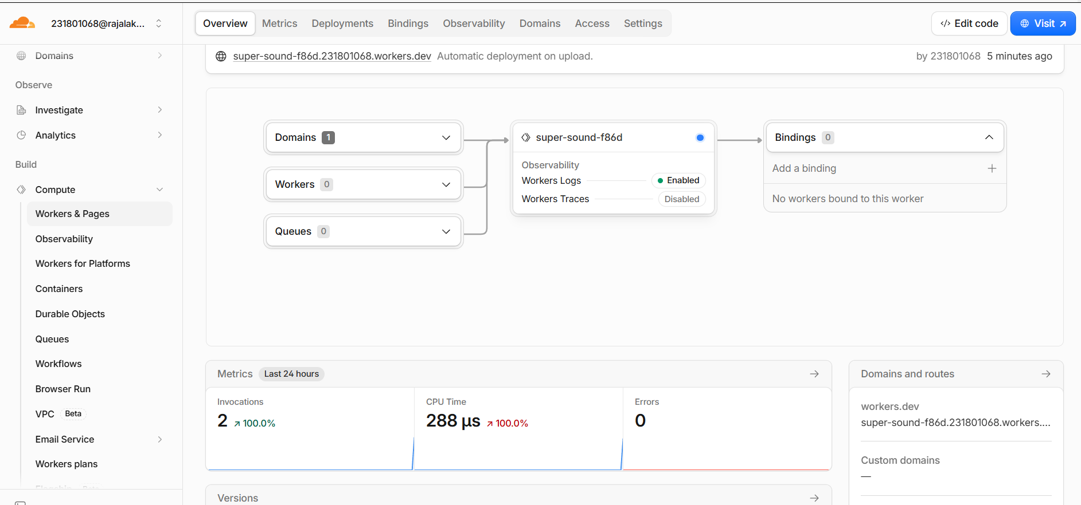
Figure 5: Dashboard metrics showing Invocations increased to 2 after visiting the Worker URL.

Step 4: Build a CDN Demonstration Page
Back in the Worker dashboard, "Edit code" was opened, and the default "Hello World!" response was replaced with a simple HTML page explaining that the content was being delivered through Cloudflare:
export default {
async fetch(request, env, ctx) {
return new Response(`
<!DOCTYPE html>
<html>
<head>
<title>CDN Experiment</title>
</head>
<body>
<h1>CDN Service Experiment</h1>
<h2>Cloudflare Content Delivery</h2>
<p>This webpage is being delivered through Cloudflare.</p>
<p>CDN reduces the distance between users and content.</p>
<p>Status: Successfully Deployed</p>
</body>
</html>
`, {
headers: { "content-type": "text/html" }
});
}
};
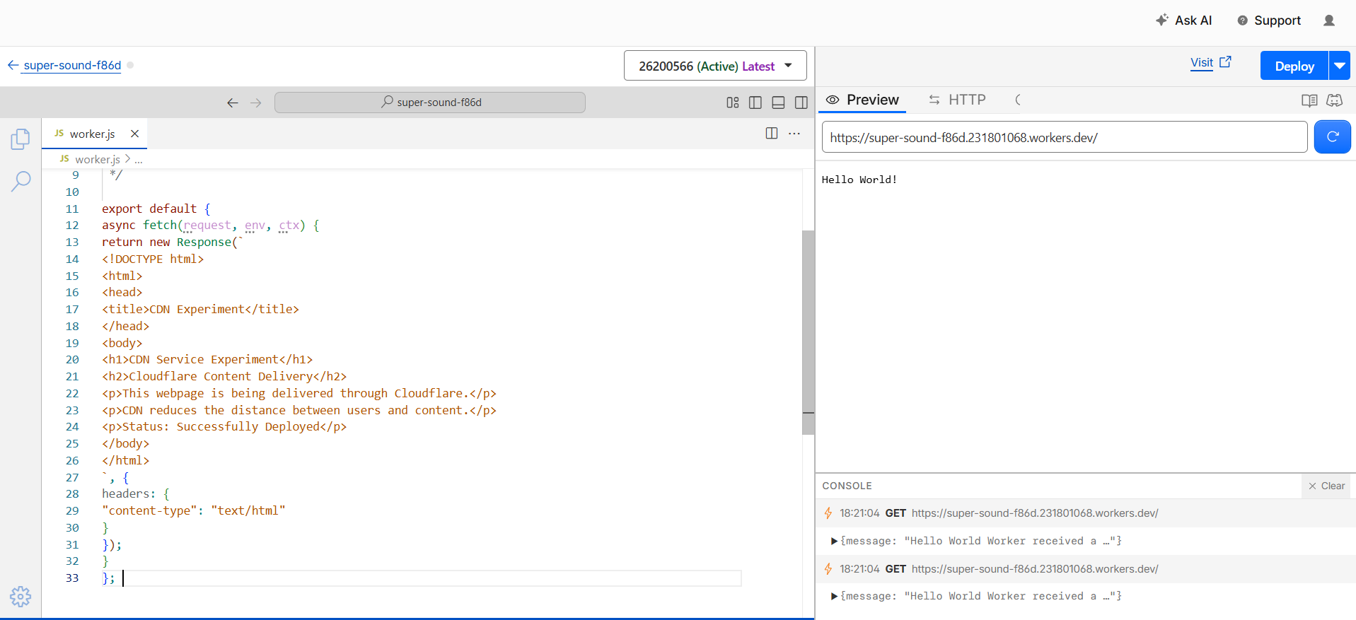
Figure 6: Cloudflare's code editor with the updated CDN demonstration page, ready to deploy.
The updated code was then deployed using the Deploy button.

Step 5: Test Again
Visiting the Worker URL again now displayed the new CDN demonstration page:
CDN Service Experiment
Cloudflare Content Delivery
This webpage is being delivered through Cloudflare.
CDN reduces the distance between users and content.
Status: Successfully Deployed
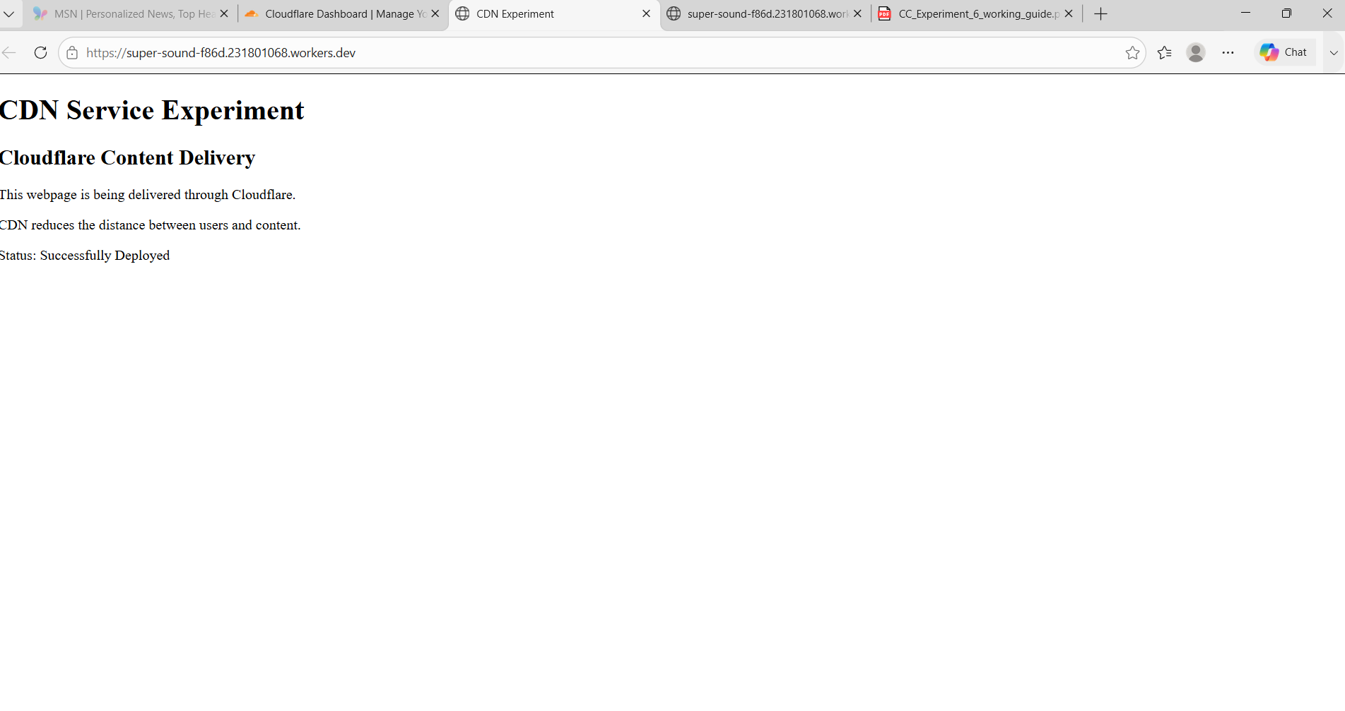
Figure 7: The updated CDN demonstration page served from the Worker's public URL.

Part C – Verifying Cloudflare Response Headers

Step 6: Inspect the Request in DevTools
With the CDN demonstration page open, DevTools was opened (F12) and the Network tab was selected, followed by a page refresh (Ctrl + R). The request for the workers.dev address was then selected.
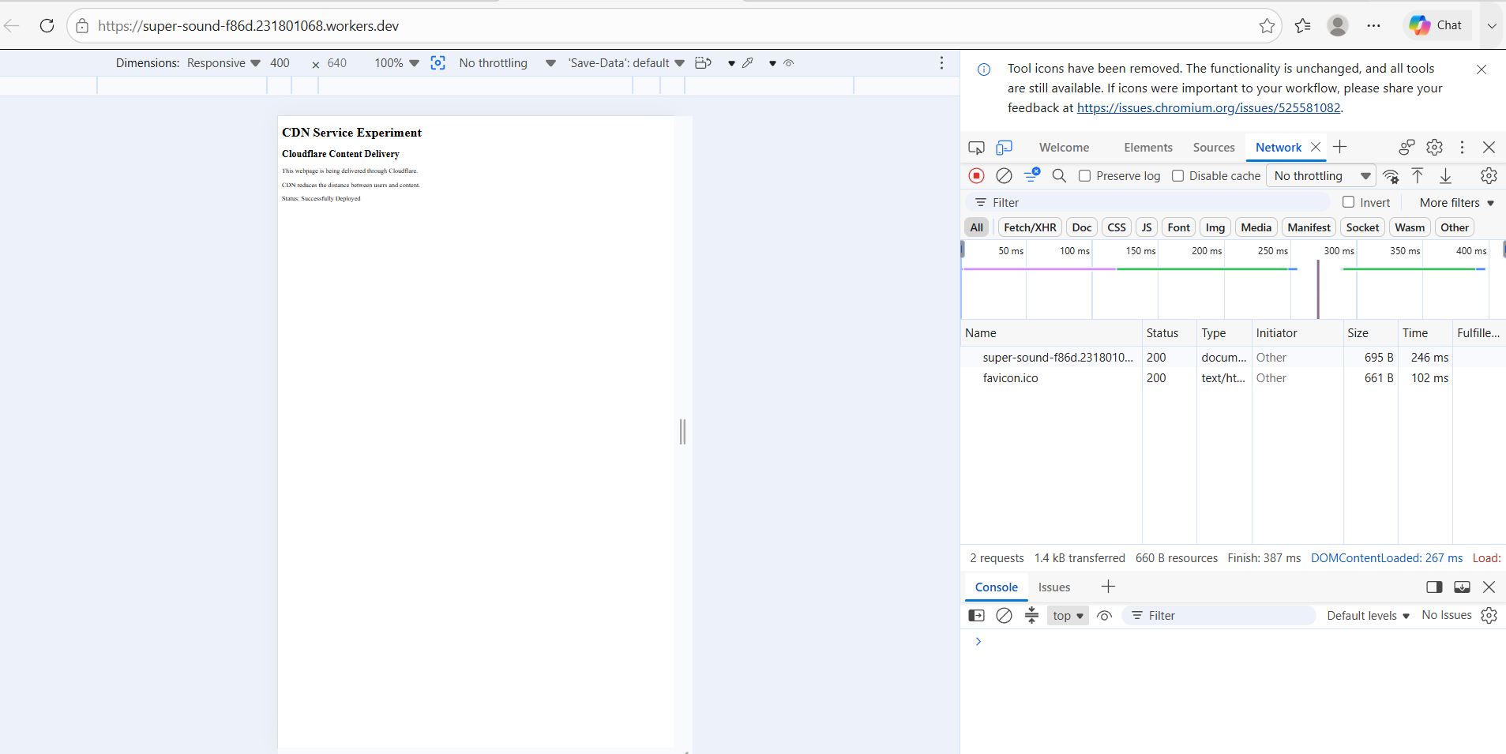
Figure 8: Network panel showing the page's two requests — the document and favicon.ico — both returning status 200.
Selecting the main request and opening its Headers tab revealed the following details:
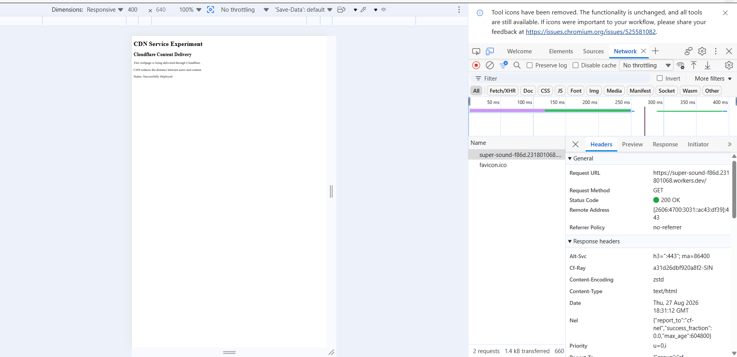
Figure 9: Request and response headers for the Worker request, viewed in DevTools.

Header-by-Header Analysis
Header / Field | Observed Value | What It Shows
Request URL | https://super-sound-f86d.231801068.workers.dev/ | The browser successfully contacted the Cloudflare Worker.
Request Method | GET | The browser requested the webpage.
Status Code | 200 OK | The server successfully received the request and returned the webpage.
Cf-Ray | a31d26dbf920a8f2-SIN | A Cloudflare request identifier used to trace a request through Cloudflare's network; the –SIN suffix indicates it was served from Cloudflare's Singapore edge location.
Content-Type | text/html | The response is an HTML webpage.
Content-Encoding | zstd | The response body was compressed by Cloudflare before delivery.

The 200 OK status, together with the Cf-Ray identifier and the workers.dev domain, confirms that the request was served through Cloudflare's edge network rather than directly from an origin server.

Conclusion
A Cloudflare-based edge content delivery experiment was successfully implemented. A Worker was deployed on the Cloudflare network and accessed through a public workers.dev URL. The browser successfully received the webpage with HTTP status 200 OK, and the response headers included Cloudflare-specific information such as Cf-Ray, confirming that the request was processed through Cloudflare's global content delivery network.

